Advanced Cloud Computing
Coursework Report
Anthony Nash

- Introduction
This report describes the implantation of a SaaS for a X-like platform called Piazza. It is designed to manage real-time user interactions within a cloud-based environment, in which users post and browse time-limited messages under specific categories.
The applications core functionalities, which are discussed in this report, include:
- Secure log-in and registration using JWT
- The ability to assign posts to specific, pre-defined topics and to browse by those topics
- A user-defined expiration time-frame for posts
- Engagement tracking (likes, dislikes, comments and an overall engagement count)
- The ability to view the most interacted-with post in a topic

- Implementation Details
The application and its RESTful API were developed in Node.js using the Express.js framework and connects to via Mongoose to a cloud-hosted MongoDB database. The application is containerized using Docker to ensure the runtime environment is identical during development and deployment. It is hosted on a Google Cloud Platform VM instance running Ubuntu and on which firewall rules are configured to allow external connection via port 3000. This set-up is illustrated in the diagram below.
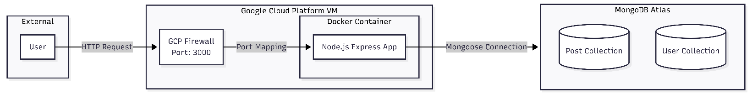

- Database design

  - User Schema
The User schema manages authentication and profile data. Each database item represents a unique, registered user

Field | Type | Description
Username | String | Unique user identifier (required)
Email | String | User’s email address (required, unique)
Password | String | Hashed representation of the user’s password

  - Post Schema

The Post schema stores all message content, including a reference to the posts creator (‘author’) to link the post to a user in the User schema

Field | Type | Description
Title | String | Post heading
Topic | String | 1 of 4 predefined categories: Health, Politics, Tech or Sport
MessageBody | String | The main content of the post
Author | ObjectId | A reference to the posters _id in the User schema
expiresAt | Date | The exact timestamp at which the posts status will be changed to ‘Expired’
Status | String | 1 of 2 values: ‘Live’ (default value for new posts) or ‘Expired’ (after expiresAt date/time reached
totalInteractions | Number | The total number of likes, dislikes and comments received for the post (see the ’Embedded sub-items’ table below)

In addition to the above items, the following sub-schema are embedded in the Post Schema and stored as arrays

Field | Type | Description
Likes | Array (Obj) | List of users who liked the post
Dislikes | Array (Obj) | List of users who disliked the post
Comments | Array (Obj) | List of sub-items containing the message and author details

The totalinteractions value for each post is calculated and updated each time a post is disliked, liked or commented on, e.g:

const newTotalInteractions = post.totalInteractions + totalChange;
const result = await Post.findByIdAndUpdate(
postId,
{ ...updateOperation, $set: { totalInteractions: newTotalInteractions } },
{ new: true }
);

Here the totalChange variable is given a value of 1 if a user likes or dislikes the post, but 0 if they have liked or disliked it 2 or more times in a row – this means each user can effectively only like or dislike a post once.

- API & Service Descriptions

  - Posts and Interactions
The API includes the end-points listed in the table below for posting, browsing and interacting with posts.

Category | Method | Endpoint | Description
Post Management | Post | /posts/ | Creates a new post with optional expirationMinutes, records author and initializes interaction counters (default:0)
 | Get | /posts/ | Returns all posts in ‘Live’ status; can filter for status and topic
 | Get | /posts/:postId | Returns all details of a specified post
 | Delete | /posts/:postId | Removes a specific post from the database
Interactions | Patch | /posts/like/:postId | Toggles ‘like’ counter for the user. If post is already ‘disliked’ by the user, removes the dislike. Updates totalInteractions value and checks to see if the post is expired
 | Patch | /posts/dislike/:postId | Toggles ‘dislike’ counter for the user. If post is already ‘liked’ by the user, removes the dislike. Updates totalInteractions value and checks to see if the post is expired
 | Post | /posts/comment/:postId | Appends a new comment object to the post's comment array
Browsing | Get | /posts/mostInt/Tech | Filters for 'Live' 'Tech' posts and returns the one with the highest totalInteractions
 | Get | /posts/mostInt/Politics | Filters for 'Live' ‘Politics’ posts and returns the one with the highest totalInteractions
 | Get | /posts/mostInt/Health | Filters for 'Live' ‘Health’ posts and returns the one with the highest totalInteractions
 | Get | /posts/mostInt/Sport | Filters for 'Live' 'Sport' posts and returns the one with the highest totalInteractions

When a post is created, the user can provide a value (in minutes) for expirationMinutes. The system immediately converts this into a fixed timestamp which is stored as expiresAt. When a post is liked, disliked or commented the system performs the following check:
const currentTime = new Date();
if (post.status === 'Live' && post.expiresAt < currentTime) {
// Synchronize DB status and block interaction
await Post.updateOne({ _id: postId }, { $set: { status: 'Expired' } });
return res.status(403).send({ message: 'Post has expired.' });

If the currentTime value is greater than the expiresAt value, the user is unable to perform the interaction and the post’s status is set to ‘Expired’. In addition, a cron task is scheduled to check for posts which have reached their expiration date; if any are found, it set their status to ‘Expired’.
When making a post, the system identifies the user by their _id and records this:

router.post('/', verifyToken, async (req, res) => {
const authorID = req.user._id;
...
const postData = new Post({
...
author: authorID,

This is then used when users perform interactions on the post. A user is unable to like or dislike his or her own post:

if (post.author.equals(authorId)) {
return res.status(403).send({ message: 'You cannot like your own post.' });
}
For Likes and Dislikes, the authorID is stored in the DB:
const author = await User.findById(authorId, 'username');
const authorName = author.username;
..
const newLike = {
type: 'like',
authorId: authorId, // Stored as an ObjectId
authorName: authorName, // Stored as a String
timestamp: new Date()
};
updateOperation: { $push: { likes: newLike } }

This enables the application to identify the user performing the action and to prevent them from adding more than 1 like or dislike to a post.
For Comments, each comment is stamped with the comment-creator’s name:

const author = await User.findById(authorId, 'username');
if (!author || !author.username) {
return res.status(404).send({ message: 'Author username not found.' });
}
const authorName = author.username;
const comment = {
authorId: authorId,
authorName: authorName,
message: message,
};
const result = await Post.findByIdAndUpdate(
postId,
{
$push: { comments: comment }
},
{ new: true }
);

The application requires that users assign their posts to one of 4 topics. It enables users to browse by these topics and to browse by status:

router.get('/', verifyToken, async (req, res) => {
try {
const { topic, status } = req.query;
const filter = {};
if (topic) {
filter.topic = topic;
}
if (status) {
filter.status = status;
} else {
filter.status = 'Live';
}
const getPosts = await Post.find(filter)
.populate('author', 'username email')
.sort({ createdAt: -1 });

The application also allows users to view the most interacted-with ‘Live’ post in each category via 4 separate API endpoints. The JavaScript code uses ‘pipelilne’ to do this by filtering the posts in 3 stages:
- It uses $match to find all live posts in the requested topic
- Then $sort is used to sort those posts in order of totalInteractions in descending order
- { $limit: 1 } is then used to return the value at the top of the list

  - User Management

The API also includes the endpoints listed in the table below for user management

Category | Method | Endpoint | Description
Registration | Post | /user/register | Saves user details in MongoDB collection
Log-in | Post | /user/log-in | Verifies user password and returns JWT token

Users are registered via the ‘register’ end point and their details are saved in the MongoDB Users collection. The version of the password saved in the database is hashed:

const salt = await bcryptjs.genSalt(5)
const hashedPassword = await bcryptjs.hash(req.body.password,salt)

When users log-in, a JWT token is created based on the users ID. This token is used to authenticate all user get, post and patch actions.

- Deployment & Containerization

  - Docker

The node.js application is containerized using Docker. I created an Alpine-based image directly on my VM:

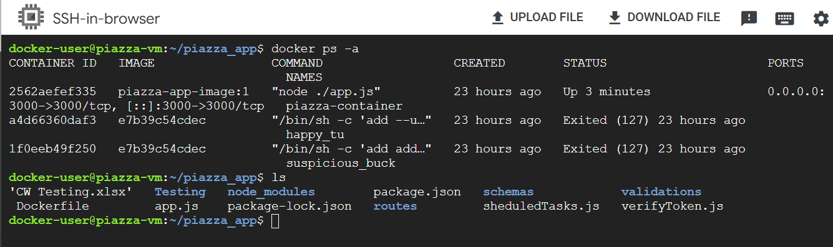

  - Cloud Deployment

My code was transferred from my laptop to the VM from my Git-Hub repo (https://github.com/anthonynash900-rgb/piazza_app.git). A specific firewall rule was created to allow TCP traffic on Port 3000 so that the cloud network would block not attempts to reach the Node.js API.

- Testing

All tests listed in the ‘Phase D: Testing your application’ section of the coursework specification (which are all represented in the table below) were tested and passed. Screenshots are provided in the final column of the table.

Test | Description | Screenshot
TC 1. Olga, Nick, Mary, and Nestor register and are ready to access the Piazza API. | Screenshots 1-4 show the successful registration of the 4 users | 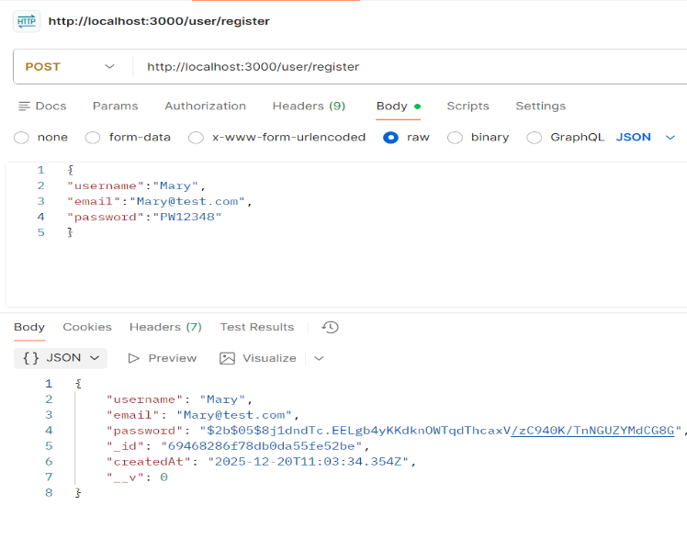  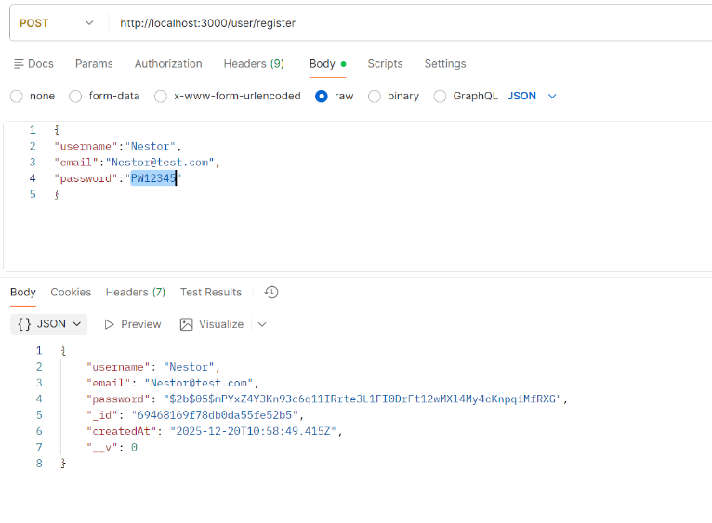  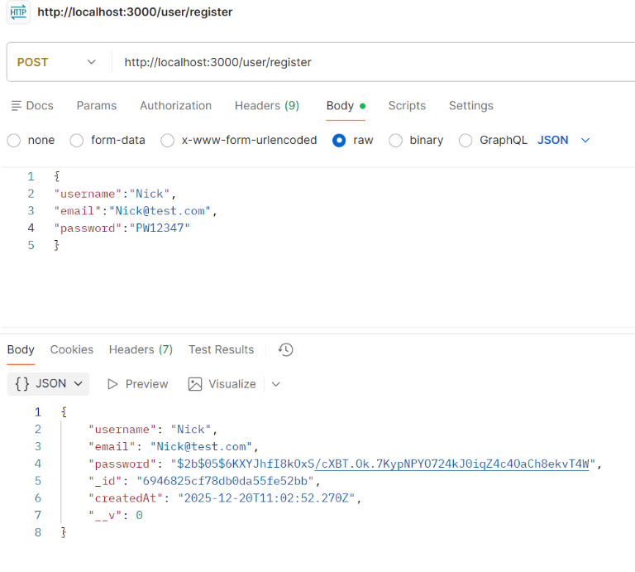  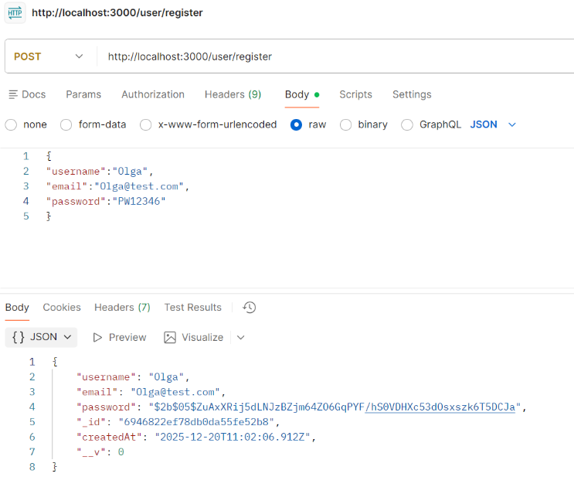
TC 2. Olga, Nick, Mary, and Nestor use the oAuth v2 authorisation service to register and get their tokens | Screenshots 1-4 show the successful log-in of each user and the JWT token returned for each | 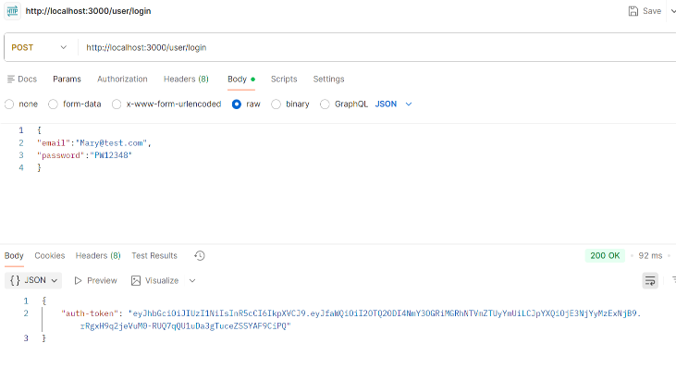  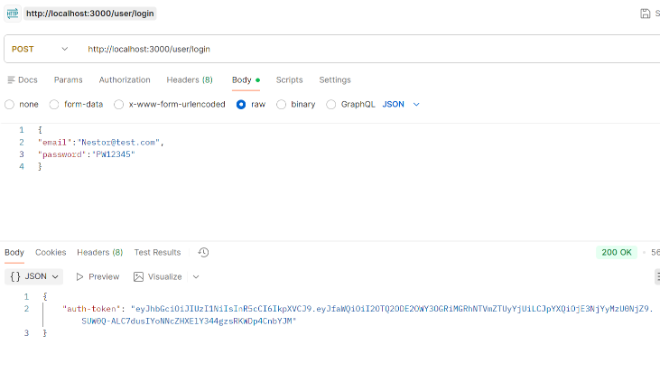  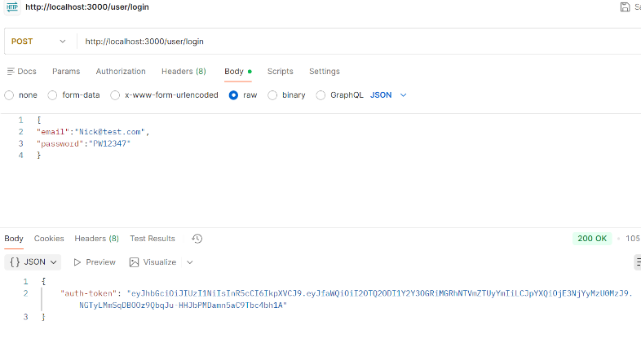  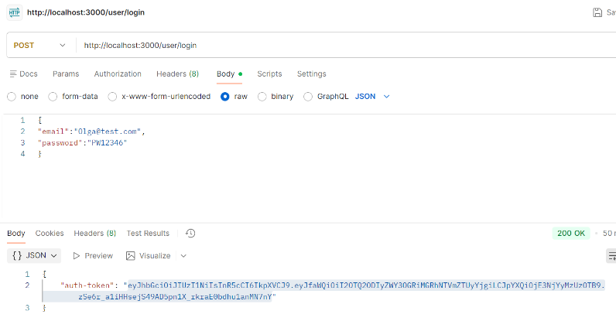
TC 3. Olga makes a call to the API without using her token. This call should be unsuccessful as the user is unauthorised | Screenshot shows Olga attempting to view posts without using her token and receiving an ‘access denied’ message | 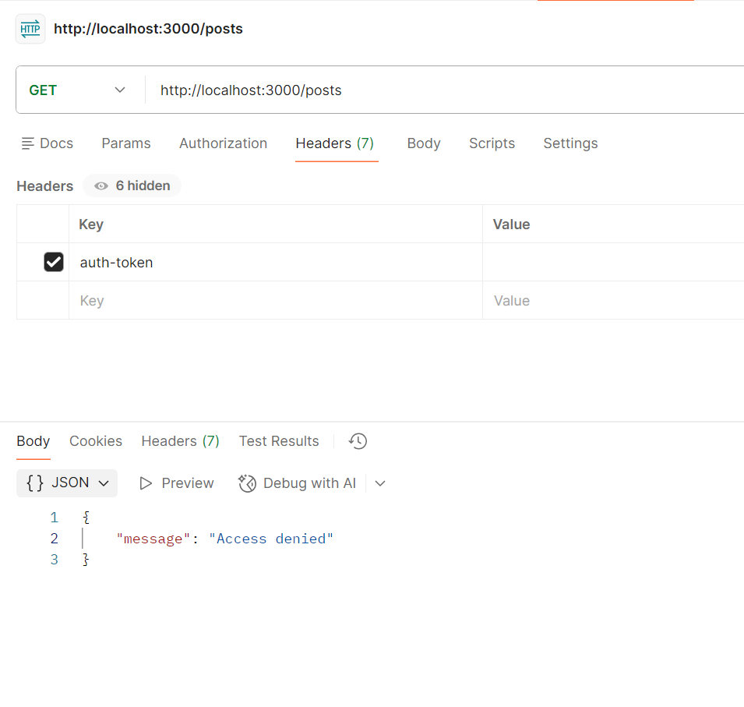
TC 4. Olga posts a message in the Tech topic with an expiration time (e.g. 5 minutes) using her token. After the end of the expiration time, the message will not accept any further user interactions (likes, dislikes, or comments). | Screenshot 1 shows Olga posting under the ‘Tech’ topic. Her post has an expiration timeframe of 5 mins  Screenshot 2 shows another user attempting to dislike the post after the 5 minute expiration window has passed and receiving an error message | 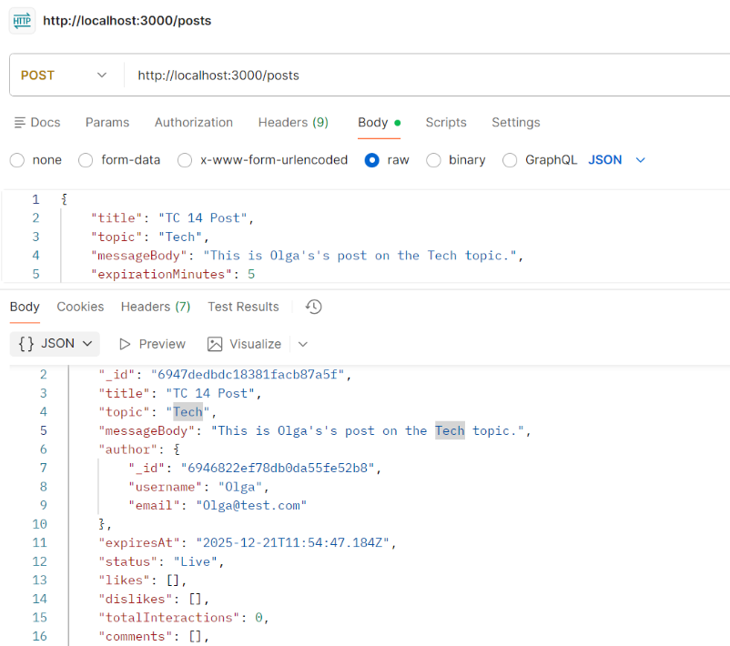  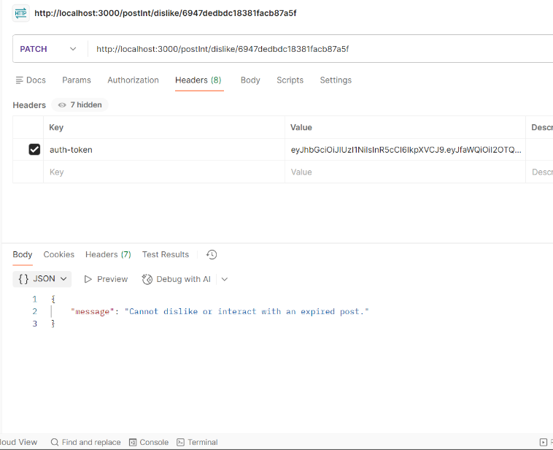
TC 5. Nick posts a message in the Tech topic with an expiration time using his token | Screenshot shows Nick posting under the Tech topic and setting an expiration timeframe of 5 minutes | 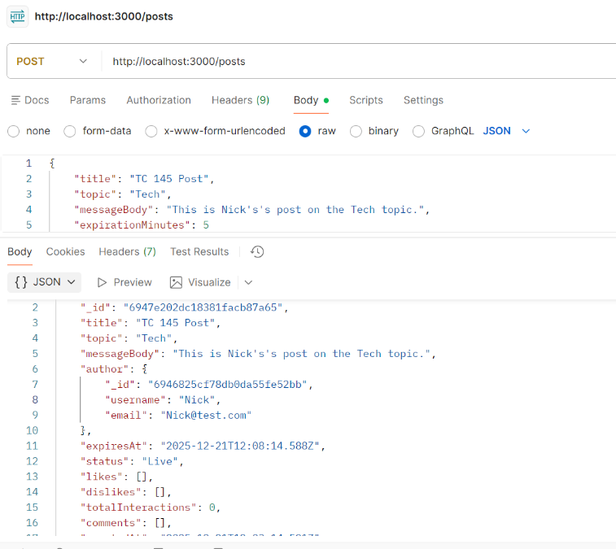
TC 6. Mary posts a message in the Tech topic with an expiration time using her token. | Screenshot shows Mary posting under the Tech topic and setting an expiration timeframe of 5 minutes | 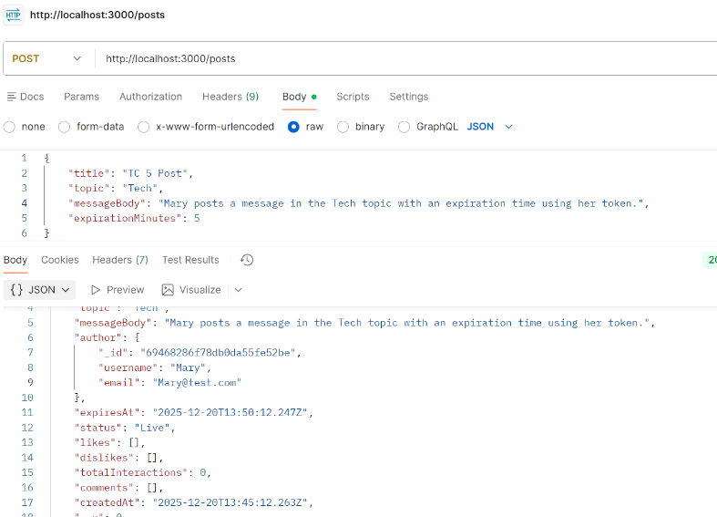
TC 7. Nick and Olga browse all the available posts in the Tech topic; three posts should have zero likes, zero dislikes, and no comments. | Screenshots 1-3 show Nick browsing all posts under the Tech topic  Screenshots 4-6 show Olga doing the same | 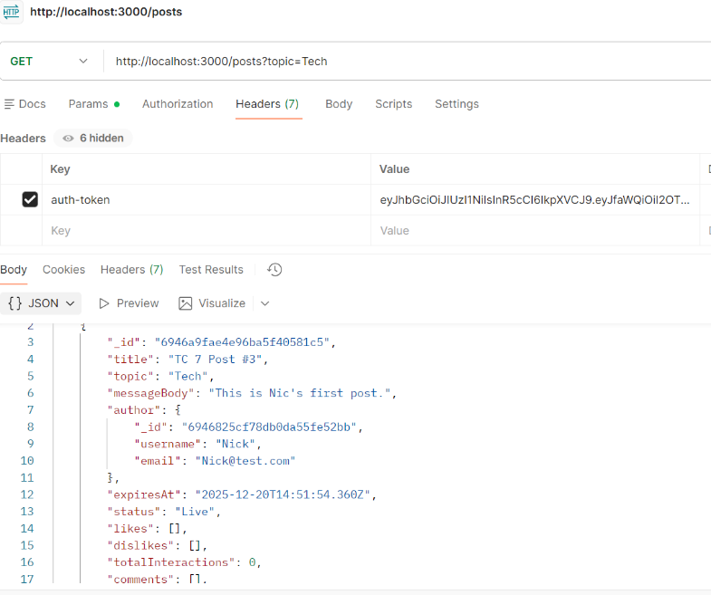  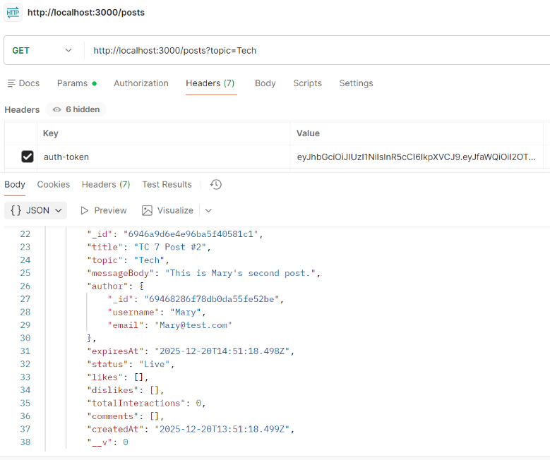  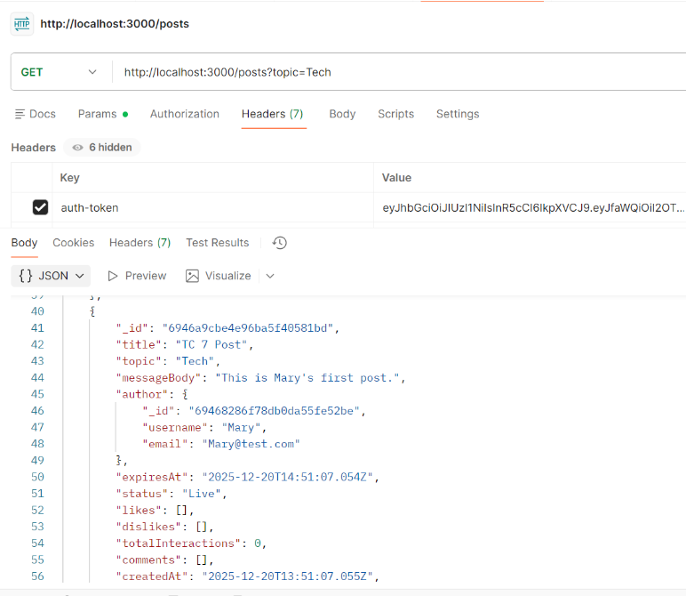  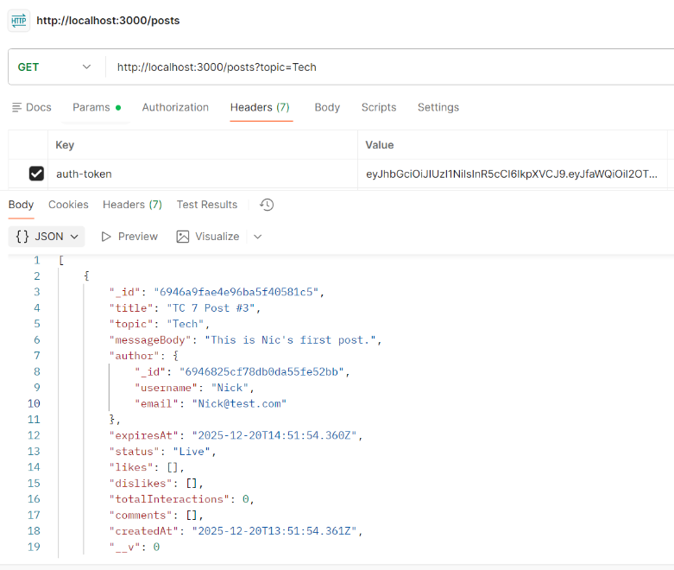  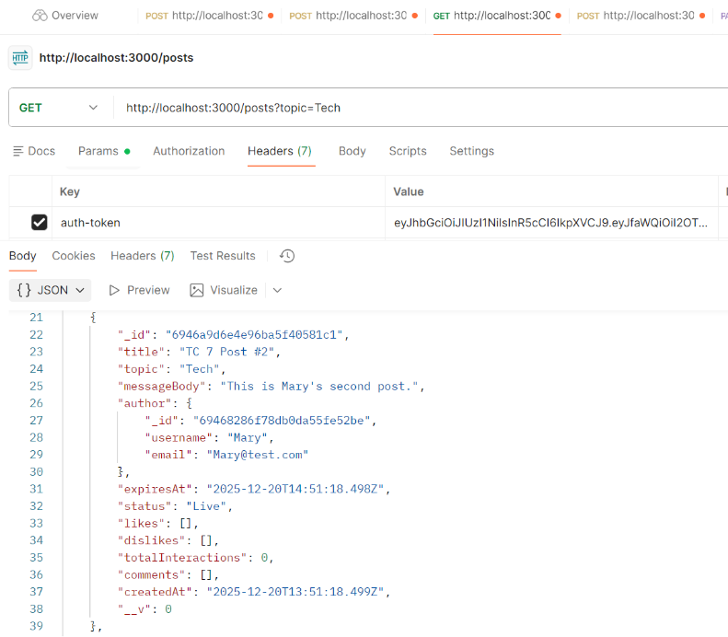  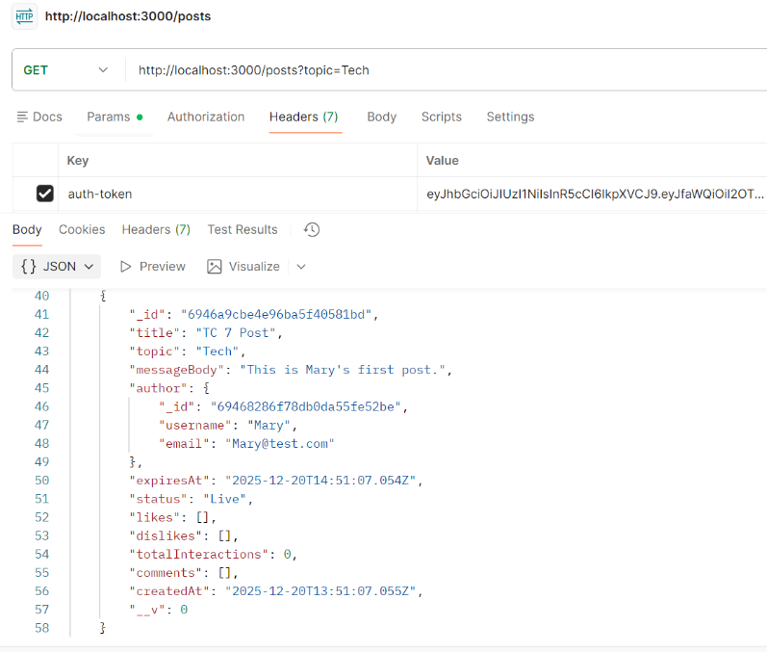
TC 8. Nick and Olga “like” Mary’s post on the Tech topic. | Screenshot 1 shows Nick liking Mary’s post  Screenshot 2 shows Olga liking Mary’s post | 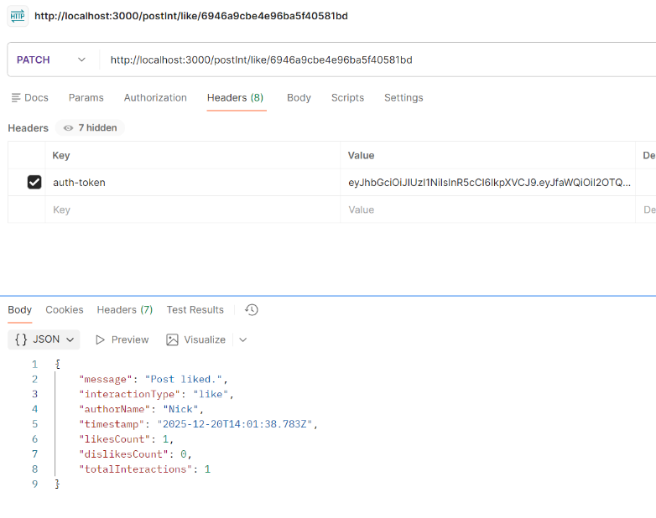  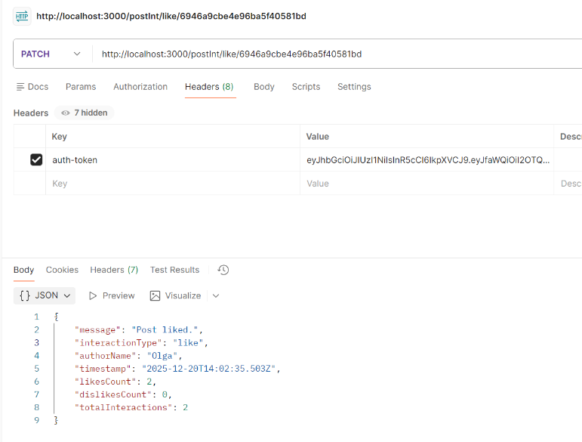
TC 9. Nestor “likes” Nick’s post and “dislikes” Mary’s on the Tech topic | Screenshot 1 shows Nestor successfully liking Nick’s post  Screenshot 2 shows Mary disliking Mary’s post | 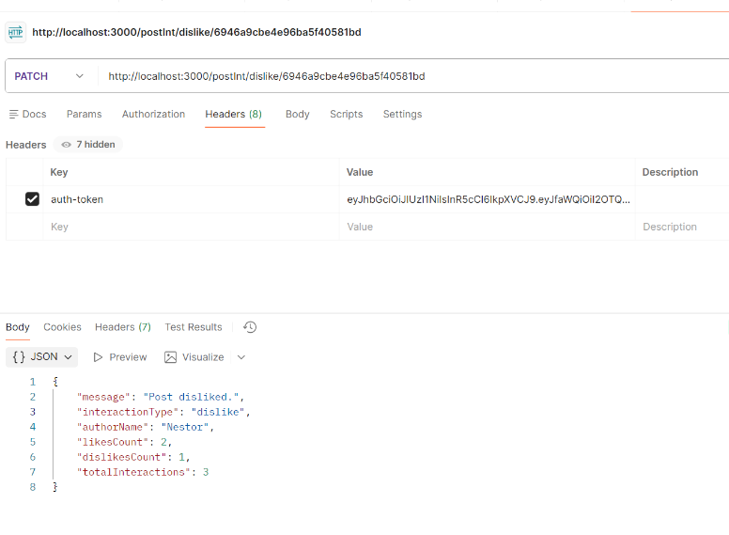  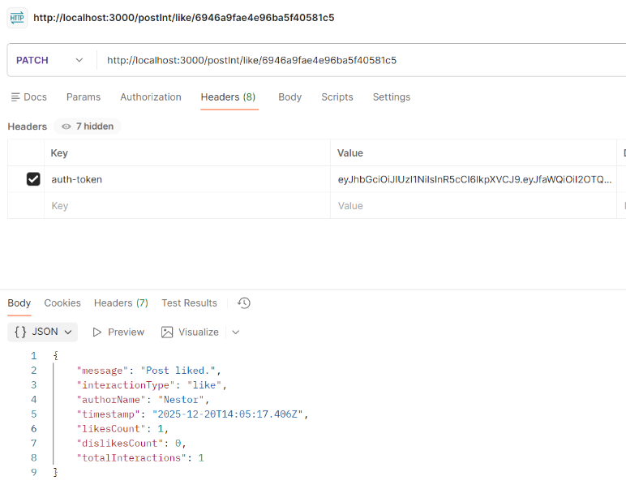
TC 10. Nick browses all the available posts on the Tech topic; at this stage, he can see the number of likes and dislikes for each post (Mary has two likes and one dislike, and Nick has one like). No comments have been made yet | Screenshots 1-3 show Nick browsing all posts in the Tech topic. The correct number of likes and dislikes are shown | 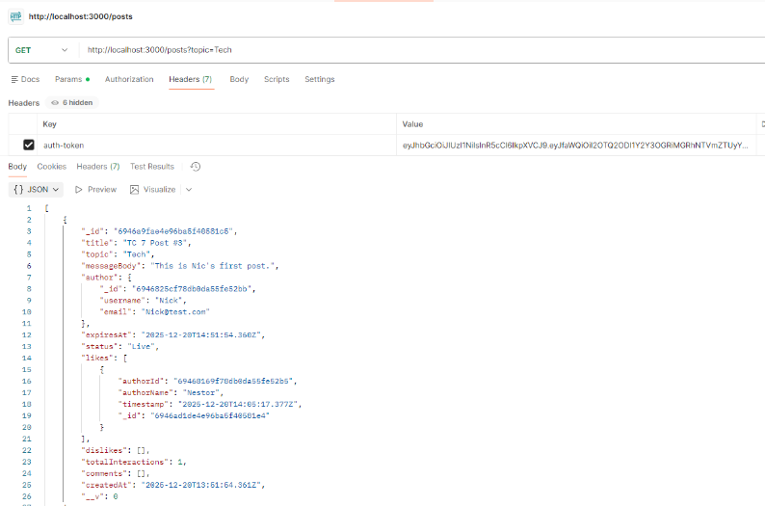  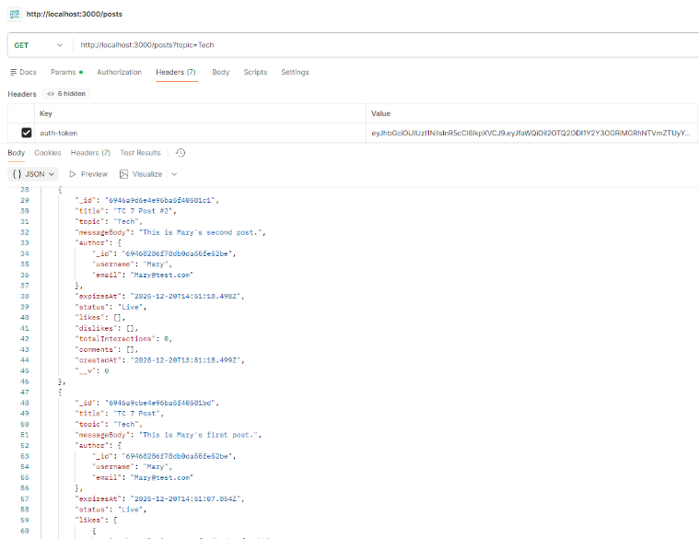  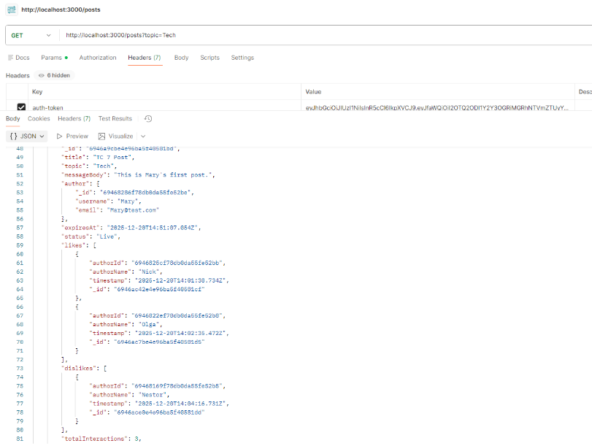
TC 11. Mary likes her post on the Tech topic. This call should be unsuccessful; in Piazza, a post owner cannot like their messages. | Screenshot shows Mary attempting to like her own post but receiving an error message | 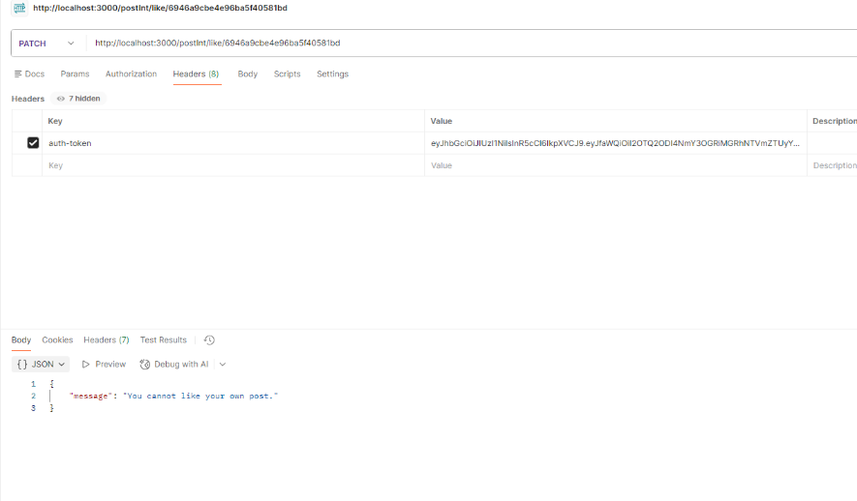
TC 12. Nick and Olga comment on Mary’s post on the Tech topic in a round-robin fashion (one after the other, adding at least two comments each). | Screenshot 1 shows Nick’s comment on Mry’s post  Screenshot 2 show’s Olga’s comment on Mary’s post | 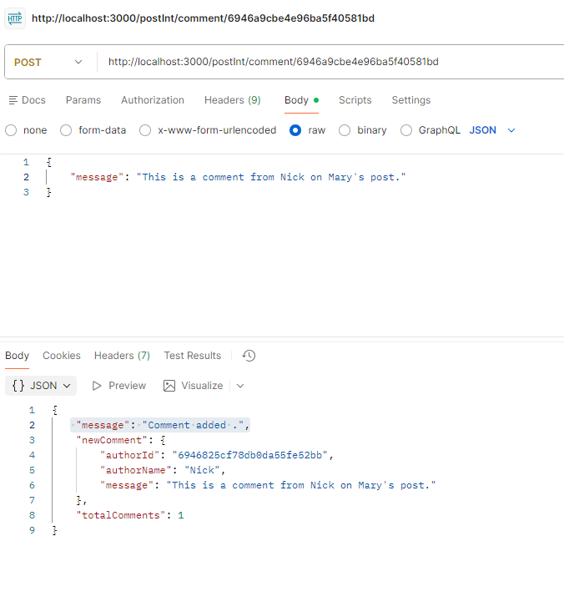  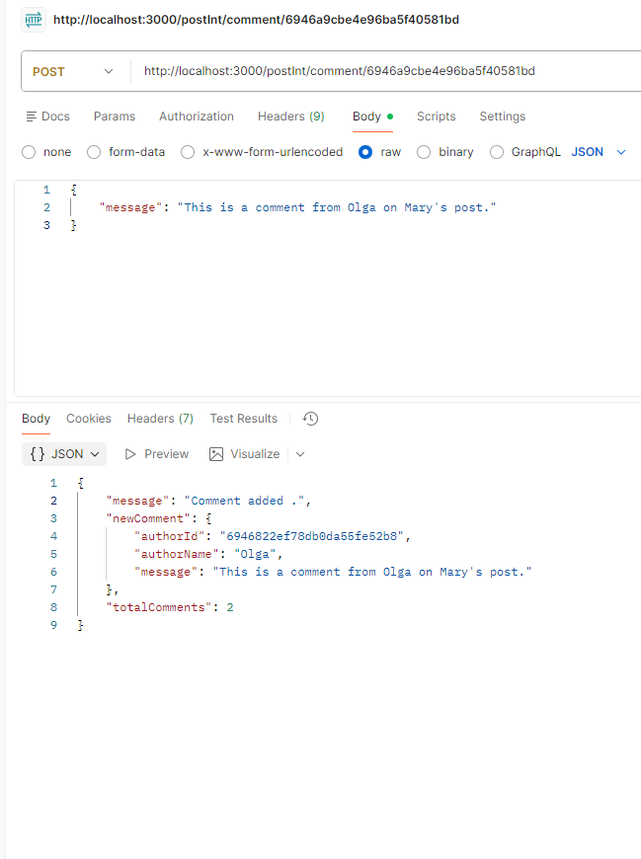
TC 13. Nick browses all the available posts in the Tech topic; at this stage, he can see the number of likes and dislikes of each post and the comments made. | Screenshots 1-3 show Nick browsing all posts in the Tech topic | 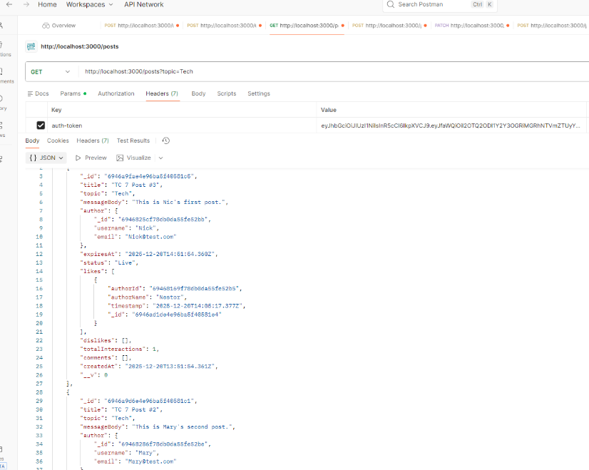  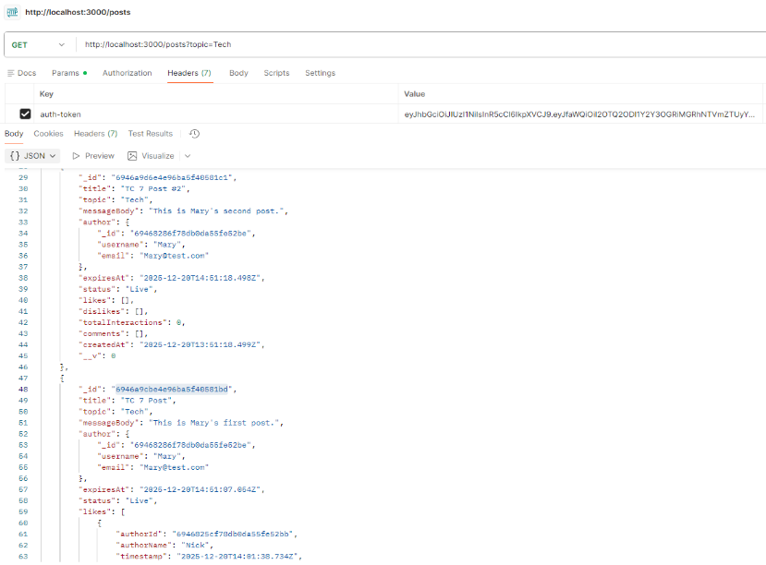  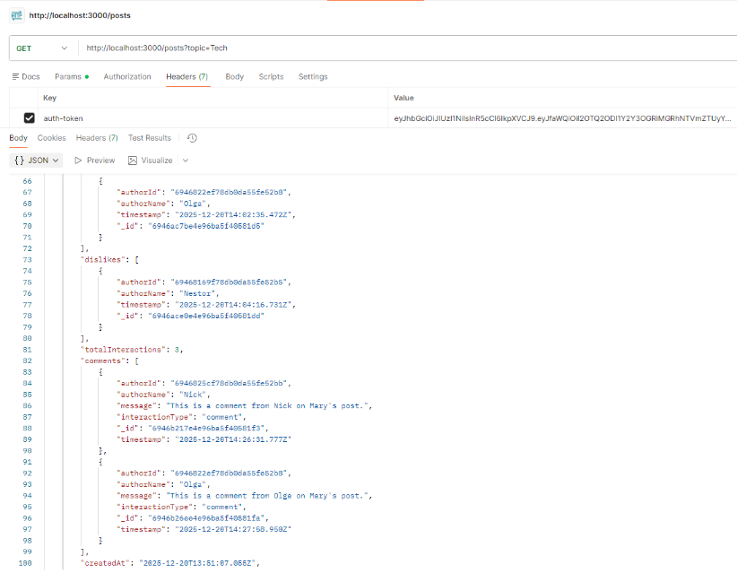
TC 14. Nestor posts a message on the Health topic with an expiration time using her token | Screenshot shows Nestor’s post under the Health topic. He has set an expiration time-frame of 10 minutes | 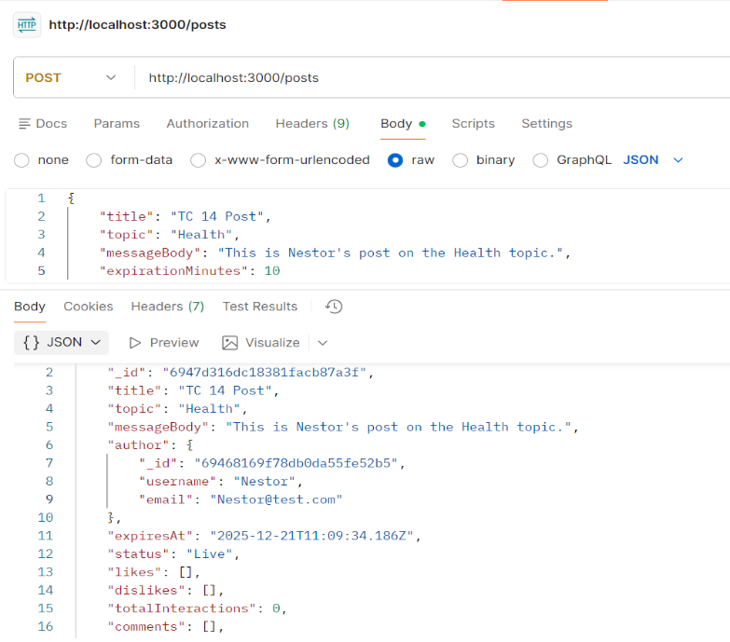
TC 15. Mary browses all the available posts on the Health topic; at this stage, she can see only Nestor’s post. | Screenshot shows Mary browsing for all posts in the Helath topic. She can only see 1 post, which is Nestor’s | 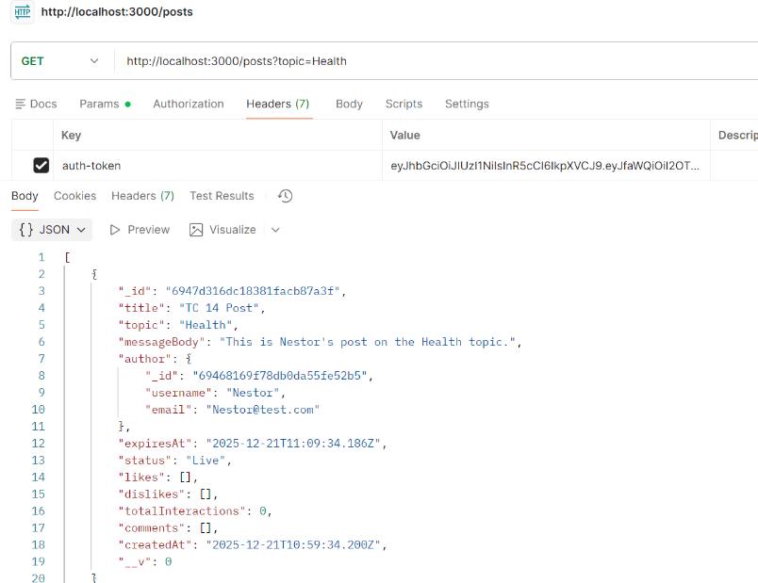
TC 16. Mary posts a comment in Nestor’s message on the Health topic | Screenshot shows Mary adding a comment to Nestor’s post | 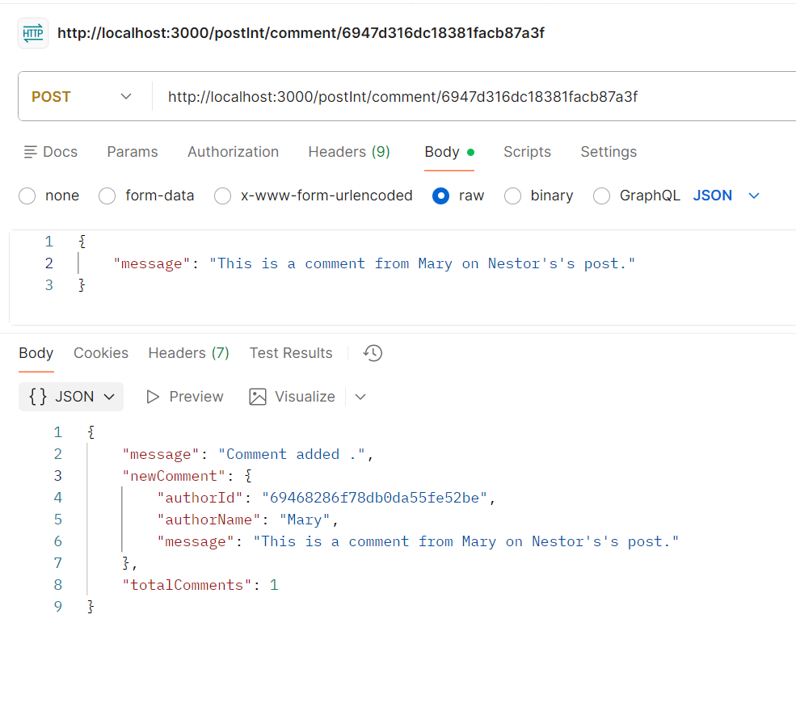
TC 17. Mary dislikes Nestor’s message on the Health topic after the end of post-expiration time. This should fail. | Screenshot shows Mary attempting to dislike Nestor’s post but receiving an error message | 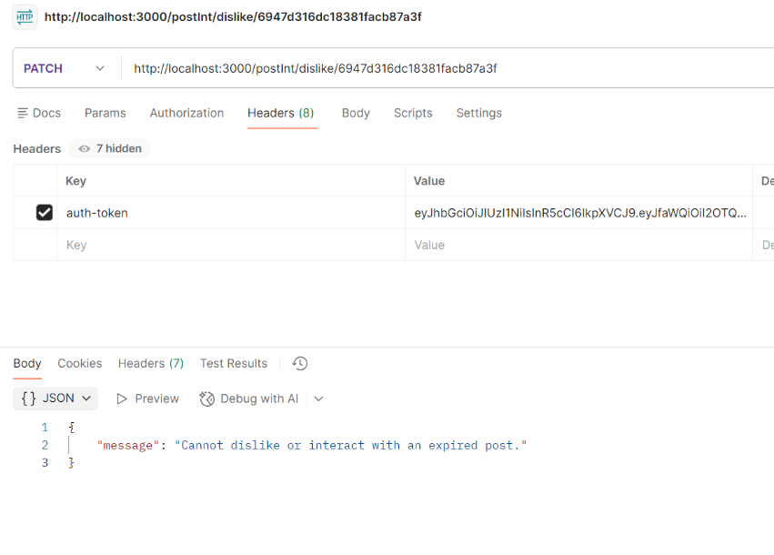
TC 18. Nestor browses all the messages on the Health topic. There should be only one post (his own) with one comment (Mary’s). | Screenshot shows Nestor searching for expires posts in the Health topic. He can only see one post (his own) which has 1 comment from Mary | 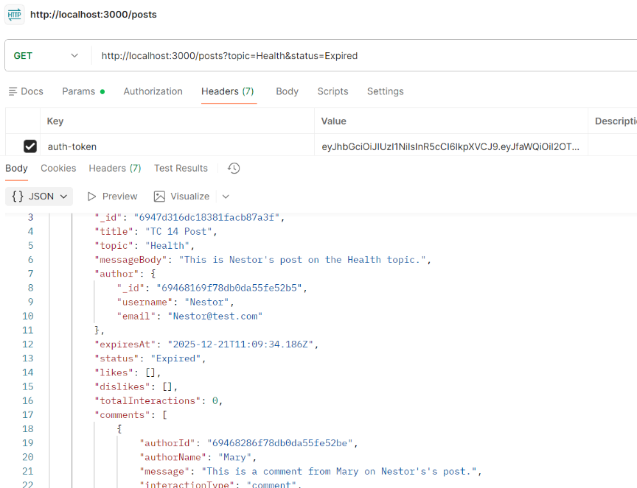
TC 19. Nick browses all the expired messages on the Sports topic. These should be empty. | Screenshot shows Nick browsing for expired posts in the Sports topic and receiving an error message showing that there are no posts to display | 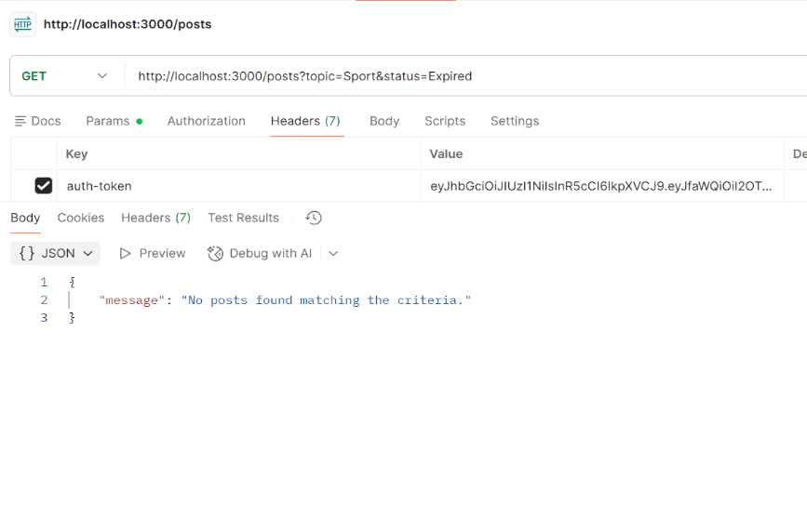
TC 20. Nestor queries for an active post with the highest interest (maximum number of likes and dislikes) in the Tech topic. This should be Mary’s post | Screenshot shows Nestor searching for the post with the greatest number of interactions in the Tech topic | 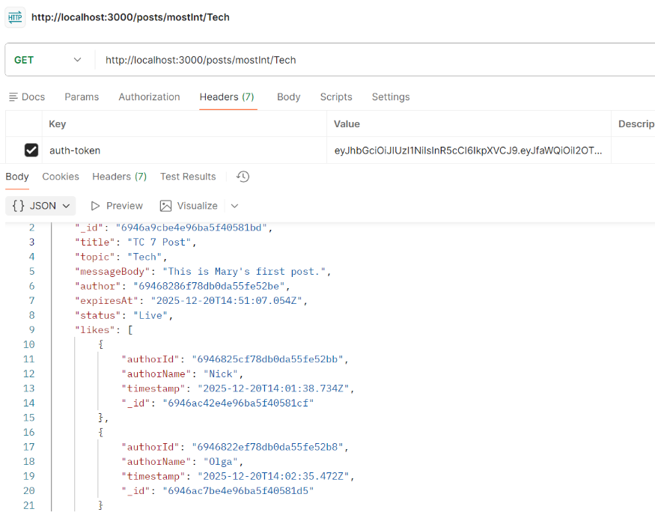

- References
I used the following online tutorials while working on this project

